M08 Chapter 14 Hands On Projects – Jadon Kosberg
- Hands-On Project 14-1
  - Use Chapter 14 Trace FileDownload Chapter 14 Trace File
  - Screenshot showing filtered packets (step 3)
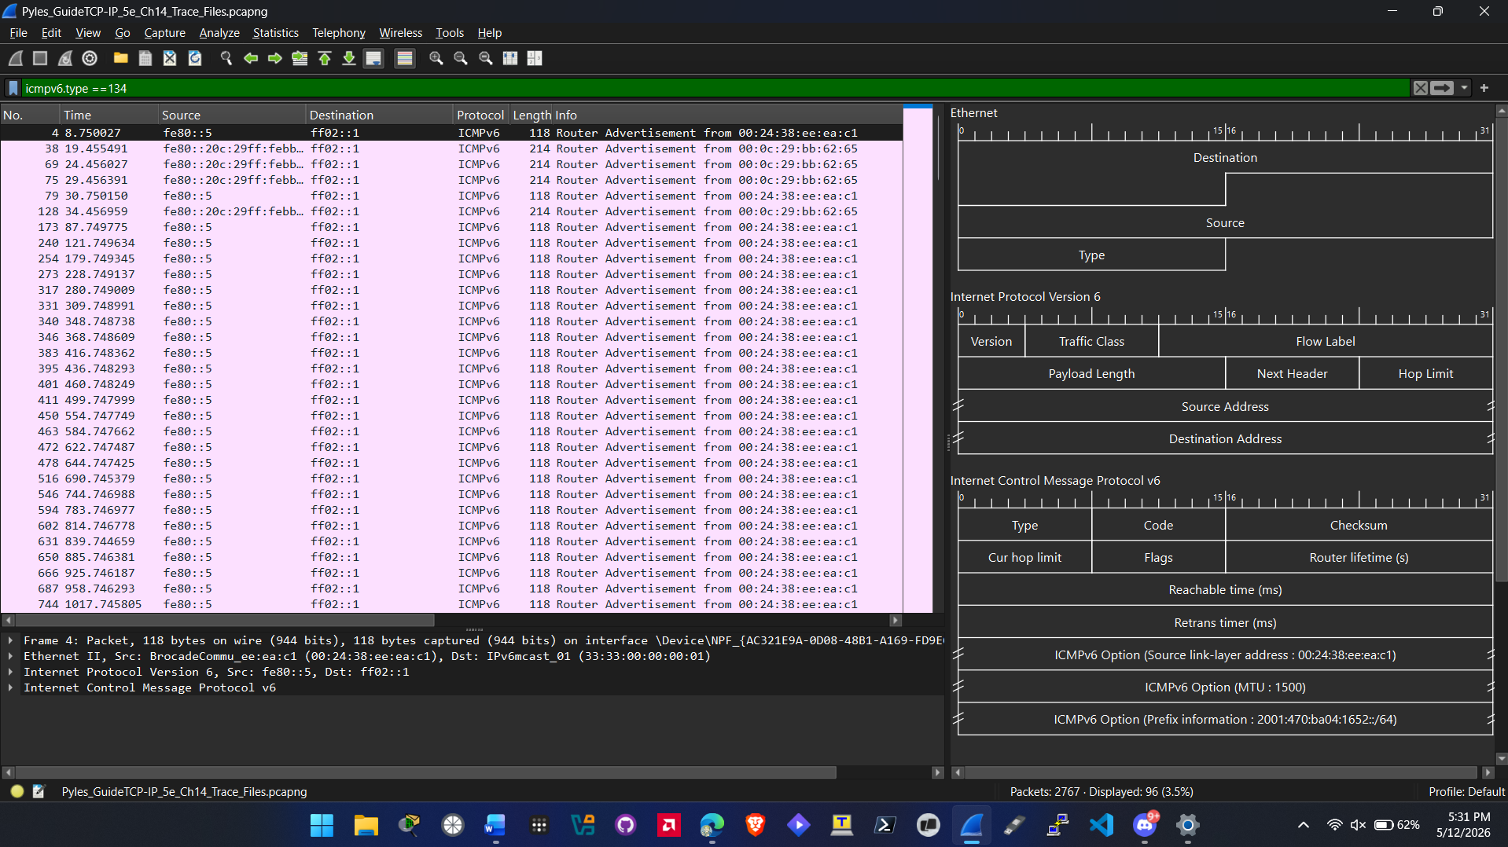
  - Screenshot showing packet with details expanded (step 4)
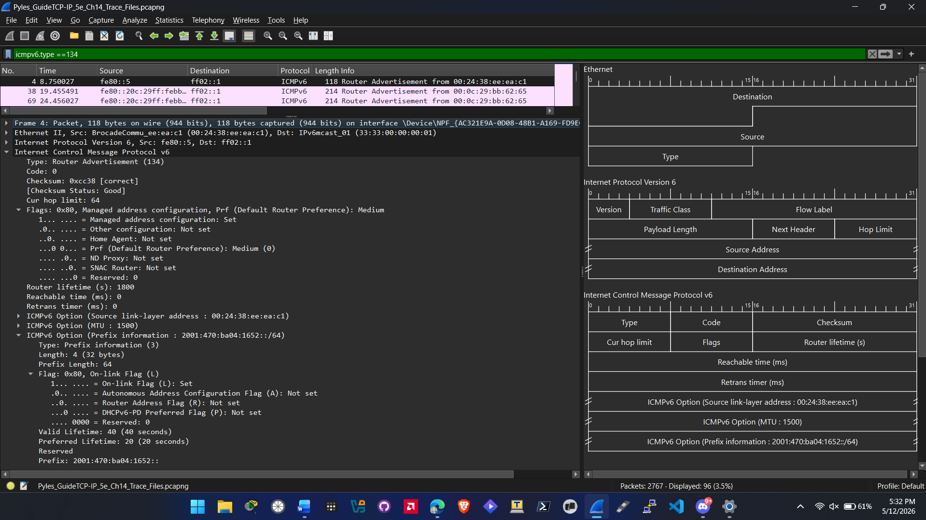
- Hands-On Project 14-2
  - Use Chapter 14 Trace FileDownload Chapter 14 Trace File
  - Screenshot showing packet with details expanded (step 4)
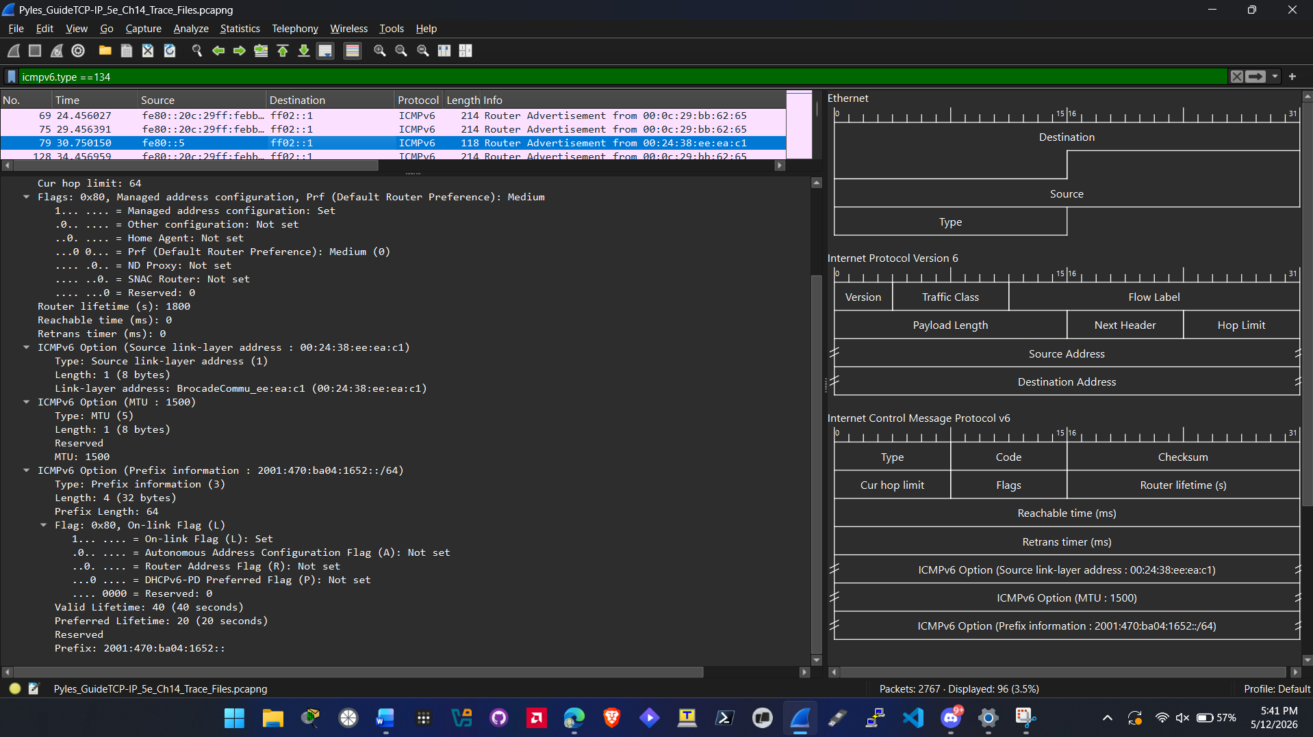
  - Screenshot showing packet with details expanded (step 6)
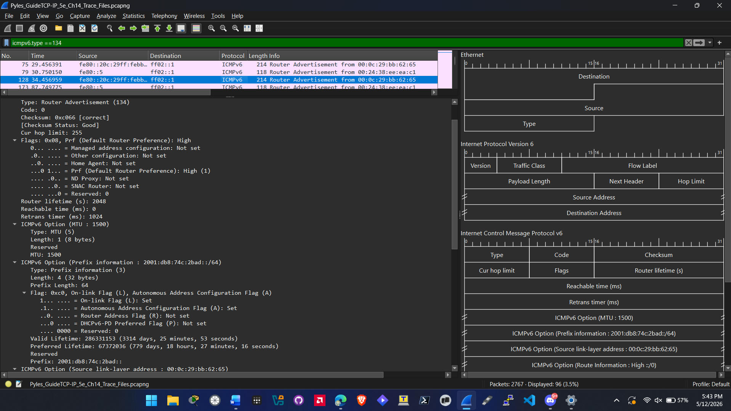
- Hands-On Project 14-3
  - Use Chapter 14 Trace FileDownload Chapter 14 Trace File
  - Screenshot showing packet with details expanded (step 4)
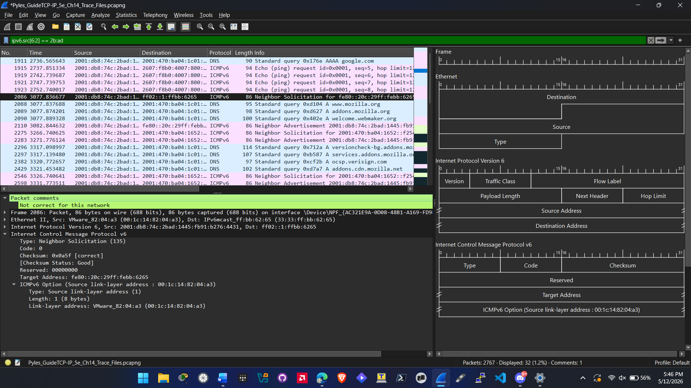
- Hands-On Project 14-4
  - Use Chapter 14 Trace FileDownload Chapter 14 Trace File
  - Screenshot showing packet with details expanded (step 4)
